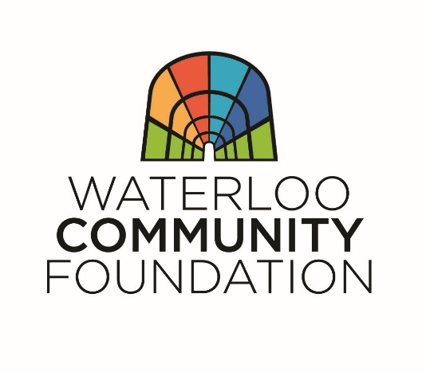
HUBERT AND GEORGIA MEMORIAL SCHOLARSHIP APPLICATION
APPLICATION DEADLINE: March 6, 2020

Hubert and Georgia not only raised their own six children, but opened up their home regularly to young people residing in the foster care system. This scholarship is established in living memory of the kindness and grace that they demonstrated for so many years. The Hubert & Georgia Rossin Scholarship is inspired also by the belief the Rossins exemplified every day: that every child deserves a loving and supportive home. This scholarship is dedicated to those wonderful individuals who sacrificed to positively make the difference in and to the life of a child by providing a loving home to those in need.

Please type or print using blue or black ink.

STUDENT INFORMATION
First Name: ______________________ Last Name: __________________________________________
Street Address: ___________________ City: _____________________ State: _____ Zip: _______
Phone: ______________________ U.S. Citizen? ____ Yes ____ No
Date of Birth: ____________________ Male ____ Female ____ (optional)
Student Email Address: ____________________________________________________________________
Parent or Guardian Name: __________________________________________________________________

SCHOOL INFORMATION
Graduation Date: __________________________________________________________________________
What post-secondary schools are you sending applications? Which do you plan to attend? _________________________________________________________________________________________
_________________________________________________________________________________________

EXTRACURRICUAR ACTIVITIES, SERVICE and WORK EXPERIENCE
Please list the organizations and activities you have been a part of throughout your high school career. If you need to add more space, attach a separate document.​​​​​​
____________________________________________________________________________________________________________________________________________________________________________________________________________________________________________________________________________________________________________________________________________________________________
_________________________________________________________________________________________

LETTERS OF RECOMMENDATION
Include 2 letters of recommendation. Letters should be one page in length and speak to the applicant’s character and why they should be granted the scholarship.​

ESSAYS
Please attach two essays. Each essay should not exceed two 8x11 pages and should be spaced at a 1.5 with a font size not to exceed 11 point font.

Essay #1: Write about your goals and aspirations for the future.
Essay #2: Write about the impact the foster care system has had on your life.

SCHOLARSHIP ELIGIBILITY
To be eligible for the Hubert & Georgia Rossin Memorial Scholarship, a student must meet the following qualifications:
- Senior enrolled at an accredited public or parochial school in Waterloo.
- Student must have been or is currently residing in a foster care home.
- Student must be in good standing at their school.
- Student must plan to attend either a two-year or four-year college/university or be actively completing a certification program of study.

PLEASE SUBMIT A COMPLETED APPLICATION AND THESE DOCUMENTS:
- Two essays (see above for content requirements).
- Two letters of recommendation (see above for content requirements).
- Copy of your most recent school transcript.

I certify that the above information is accurate.

Signature: ___________________________________________________________________________
Name (printed): ____________________________________________ Date: ___________________

OTHER
- Applications may be hand-delivered or mailed and received by 5 pm on March 31, 2020. Late applications will not be accepted.
- Selection of scholarship recipient based on thoroughness of application, essay, transcript, and letters of recommendation.
- Send completed application and supporting attachments to:

Waterloo Community Foundation
425 Cedar Street, Suite 320
PO Box 1253
Waterloo, IA 50704

Questions?
Michelle.Temeyer@wloocommunityfoundation.org
319.883.6022

THANK YOU FOR APPLYING!

