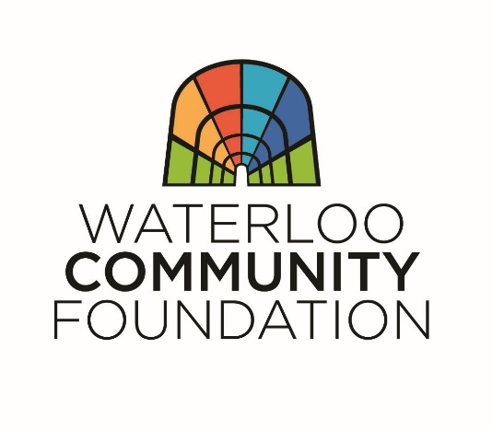
QUEST SCHOLARSHIP APPLICATION FORM
APPLICATION DEADLINE: MARCH 6, 2020

Please type or print using blue or black ink.

STUDENT INFORMATION
First Name: ______________________ Last Name: __________________________________________
Street Address: ___________________ City: _____________________ State: _____ Zip: _______
Phone: ______________________ U.S. Citizen? ____ Yes ____ No
Date of Birth: ____________________ Male ____ Female ____ (optional)
Student Email Address: ____________________________________________________________________
Parent or Guardian Name: __________________________________________________________________

SCHOOL INFORMATION
Name of High School you are currently attending: ________________________________________________
What post-secondary schools are you sending applications? _______________________________________
_________________________________________________________________________________________

EXTRACURRICUAR ACTIVITIES, SERVICE and WORK EXPERIENCE
List extracurricular activities. ________________________________________________________________ ___________________________________________________________________________________________________________________________________________________________________________________________________________________________________________________________________________
_________________________________________________________________________________________

List volunteer activities and hours of service for each (16 hours minimum required during senior year). ________________________________________________________________________________________________________________________________________________________________________________________________________________________________________________________________________________________________________________________________________________________________

List work experience and the average number of hours worked per week. ____________________________ ________________________________________________________________________________________________________________________________________________________________________________

ONE PAGE ESSAY
Please ATTACH one typed-written page addressing the following:
- What are your long-term or career goals/plans, how do you intend to achieve them, and why did you choose these goals/plans?
- What personal characteristics or experiences qualify you to receive a scholarship?

SCHOLARSHIP ELIGIBILITY
To be eligible for the Quest Scholarship, a student must meet the following qualifications:
- Be enrolled at a high school in the Waterloo School district and planning to attend an accredited public college or university or community college in Iowa as a full-time student starting in the fall 2020.

- Pursuing a career in field of education or science, technology, engineering or mathematics (STEM).
- Minimum grade point average of 2.9.
- Minimum of 16 hours of volunteer service during senior year.
ATTACHMENTS
- One-page essay (see above for content requirements).
- A letter of recommendation emphasizing leadership qualities from a teacher, principal, counselor, church leader, community leader, or employer (not a family member).
- Copy of your most recent school transcript.

I certify that the above information is accurate.

Signature: ___________________________________________________________________________
Name (printed): ____________________________________________ Date: ___________________

OTHER
- Applications may be hand-delivered or mailed and received by 5 pm on Friday, March 6, 2020. Late applications will not be accepted.
- Selection of scholarship recipient based on thoroughness of application, essay, transcript, volunteer experience, SAT/ACT scores and letter of recommendation.
- Send completed application and supporting attachments to:

Waterloo Community Foundation
425 Cedar Street, Suite 320
PO Box 1253
Waterloo, IA 50704

Questions?

Michelle.Temeyer@wloocommunityfoundation.org
319.883.6022

THANK YOU FOR APPLYING!

